|  |
| --- |
|  |
| WEB DESIGN PROJECT REPORT  [CODE MASTER ACADEMY](http://codemasteracademy.gear.host/index.html) |
| |  |  |  | | --- | --- | --- | |  | December 2016 |  | |

**Table of Contents**

1. Design 2

1.1. PROJECT PROPOSAL 2

1.1.1. Project Overview 2

1.1.2. Research / Investigation 2

1.1.3. Requirements & Technical Approach 2

1.2. WIREFRAME / SITEMAP 3

2. Development 5

1.3. PRODUCTION LOG 5

1.3.1. Development Process 5

1.3.2. Validation 5

1.3.3. Deployment 14

1.4. PROJECT TEAM 15

1.4.1. Break Down of Tasks 15

1.4.2. Team Issues 15

1.5. CONCLUSION 15

1.5.1. Result, Achievements, and Possible Changes to be Added 15

1.6. REFERENCES & APPENDIX 15

# Design

## PROJECT PROPOSAL

### Project Overview

Code Master Academy is a website dedicated to a fictional web design school located in Dublin Ireland.

Our early ideas for the design were to create a clean, smooth and responsive website that looks professional and eye-catching. Our main goal was to structure the page in a way which would create a user-friendly interface and an extraordinary user experience.

### Research / Investigation

The companies we looked at to get familiarized with the standard layout of our competitors have adopted to their websites were:

[Open Class Rooms](https://openclassrooms.com/), a company which provides online courses in web development, entrepreneurship, design, and general technology fields. The French government recognizes the company’s degree.

[Codecademy](https://www.codecademy.com/), another online and very well-known open courses company that provides courses in the web development, programming, design and general technology.

[CCT](https://www.cct.ie/), a physical QQI college located in Dublin, Ireland that offers part-time and full-time courses in the technology and business fields, such as: web design & development stream, design stream, bachelor of science in information technology, bachelor of business and so forth.

[Jon Duckett websites on CSS & HTML/ Java Script & JQURY](http://www.htmlandcssbook.com/)

We found Jon’s website very inspiring and it gave us lots of great information on how to build basic websites. We found his websites very clean and well structured.

After looking at all those websites, we decided to create something cleaner and simpler. We found some of the websites to be clattered with content and superfluous information. However, we followed the same style of layout and we’ve used similar choice of colours to give the website a nicer feel.

### Requirements & Technical Approach

One of the main requirements involved in our project was the functional integration of our conceptual designs while on the other hand researching our competitor’s websites and implement some ideas which would nicely integrate with our ideas and concepts.

We started to create our first drafts using mostly HTML and basic CSS and discarding few of our first ideas until we got to the desired website we had planned from the beginning. Our research was not only based on our classes material; it was also based on online and book research to achieve some of our goals.

Books researched:

Jon Duckett – HTML & CSS, Java Script & JQuery, McFarland – CSS the missing manual

Tools used: Adobe Bracket, Adobe Photoshop CS6, Adobe Colour Picker.

## WIREFRAME / SITEMAP

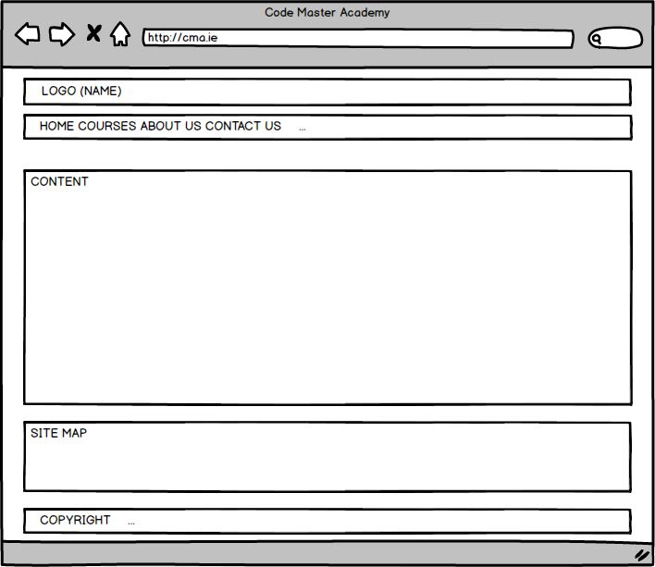

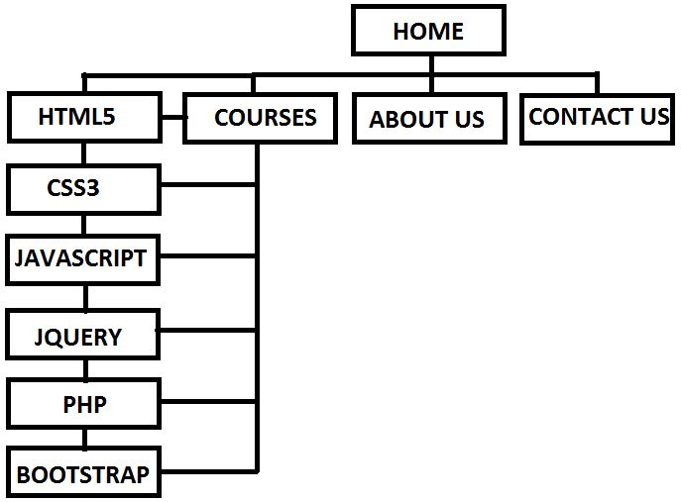

# Development

## PRODUCTION LOG

### Development Process

Our development process was quite straight forward because we had already studied web design in the past, we had most of our design and what we were expecting from our website already set before starting coding. We have used certain books and previous knowledge to build our website, the basic structure of the website comes from HTML & CSS, by Jon Duckett’s book, which has been heavily modified to represent our needs and ideas.

Our website structure has a common feature like a header and a footer enclosed in a container created with a div element to display our college’s name on the top of every webpage. As we continued further down the page we created a vertical inline navigation bar for the user to navigate between the pages.

Our first three pages contain a div called feature used to display a different image to each of those pages.

The main body with the content for each of the pages is differently structured to satisfy different content requirements we had planned since its begin.

Other common parts of some of the webpages are the 3 to 6 main columns designed with fluid design.

The last common element on the page is the footer where we implemented a JavaScript code to update it to the current year.

### Validation

Our Courses and About Us pages did not present any error after validating it.

Our index page, however, presented few errors related to extra space in all the anchor tags, e.g. <a href="courses.html #html">, after fixing all these errors and validating our index.html page again no errors were found.

Our contact page also presented few errors, such as: unnecessary use of the </br> tag inside the table, wrong input type for one of the elements in our table, e.g. <td><input type="type" name="sname" maxlength="40" placeholder="Surname"/>, input tag not properly closed, e.g. <td><input type="text" name="email" placeholder="Email</td>, the type for this input has also been changed to the email type, one <tr> tag was not properly closed inside the table as well.

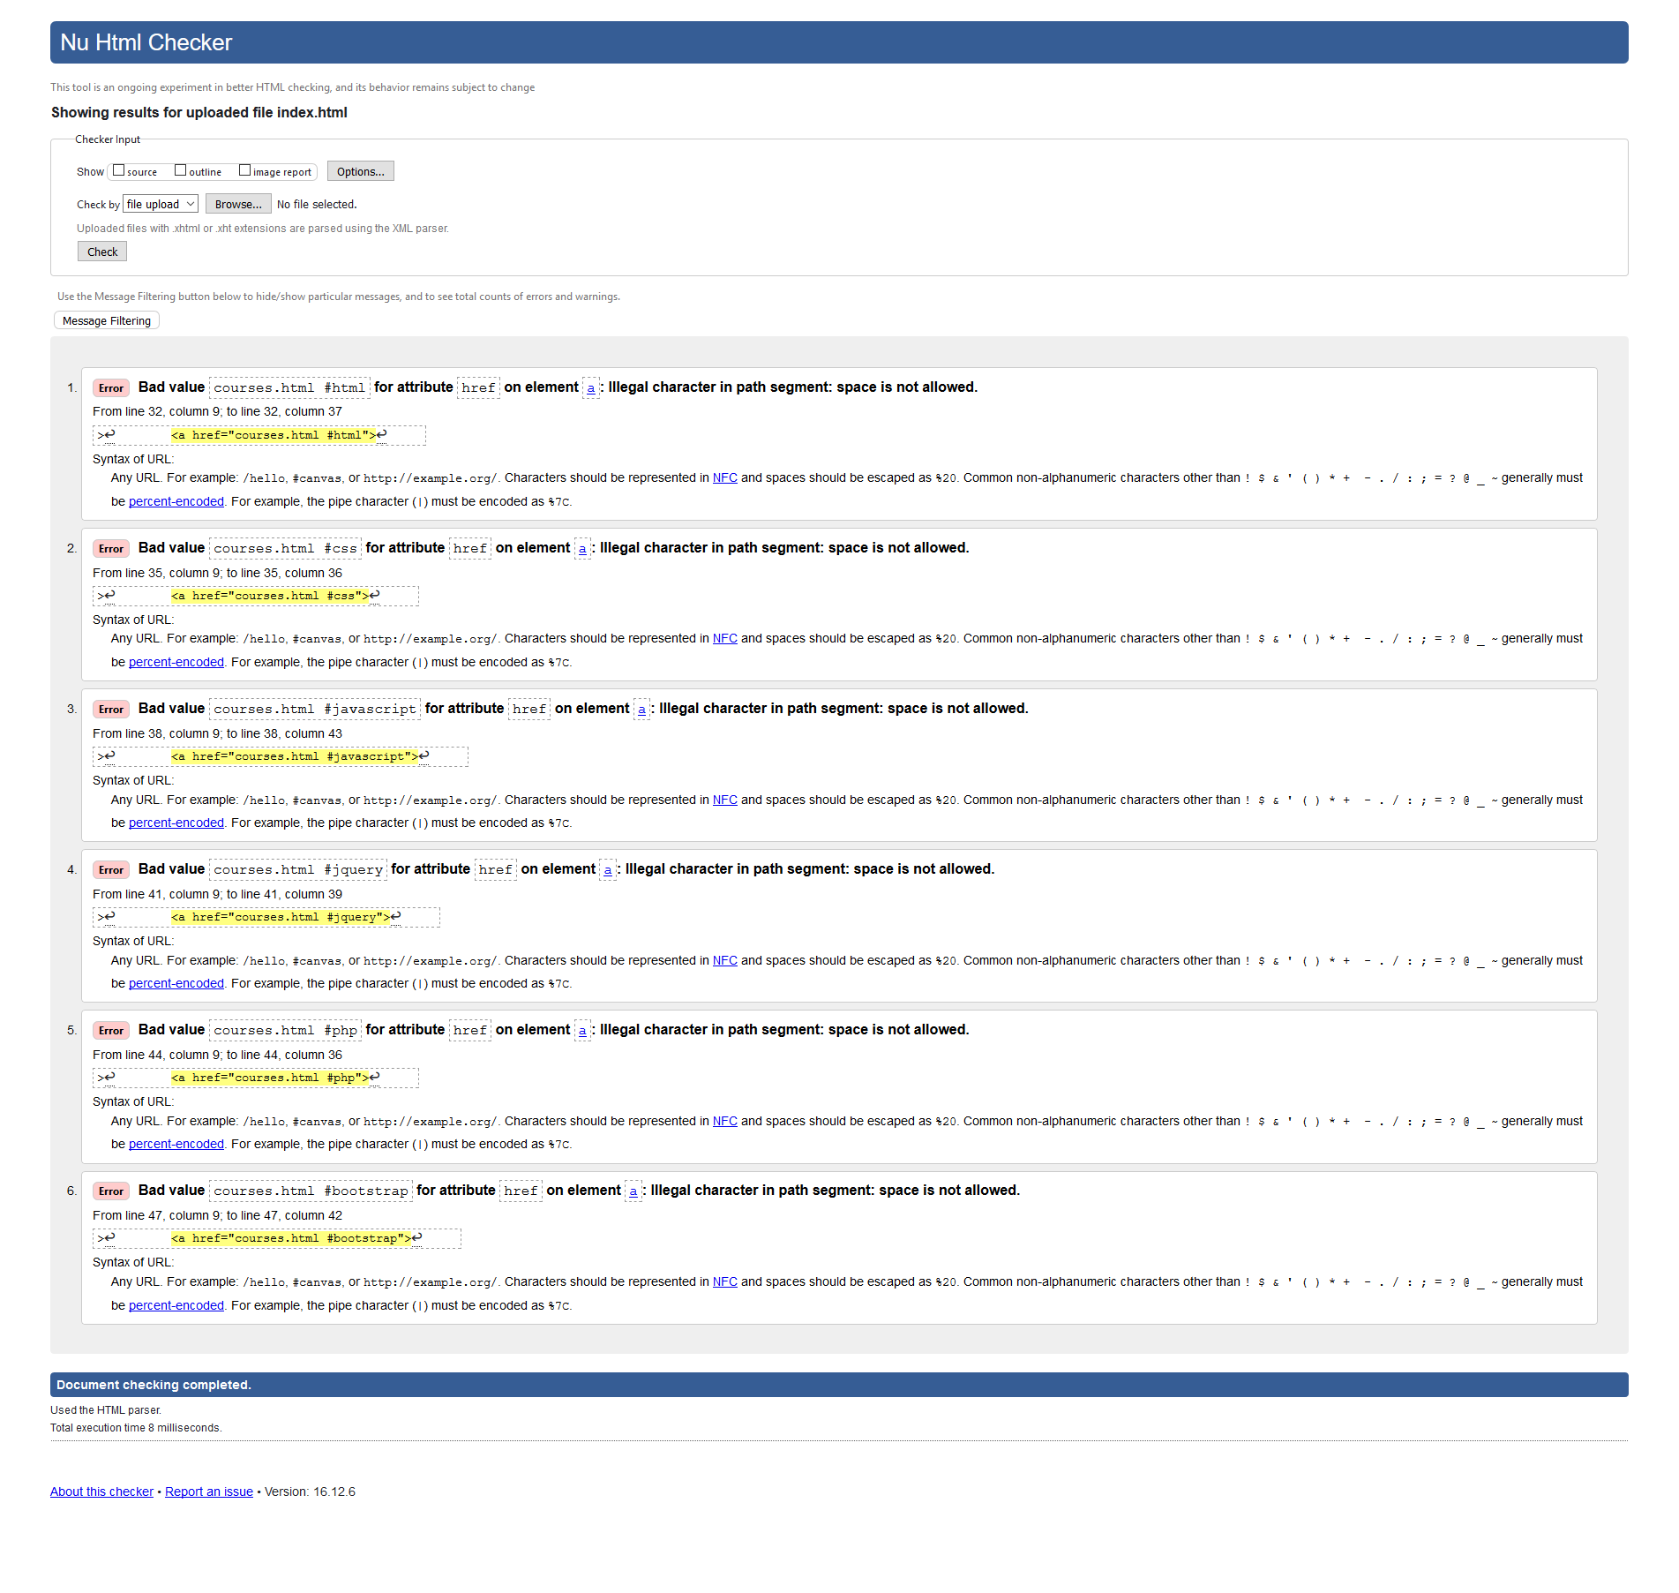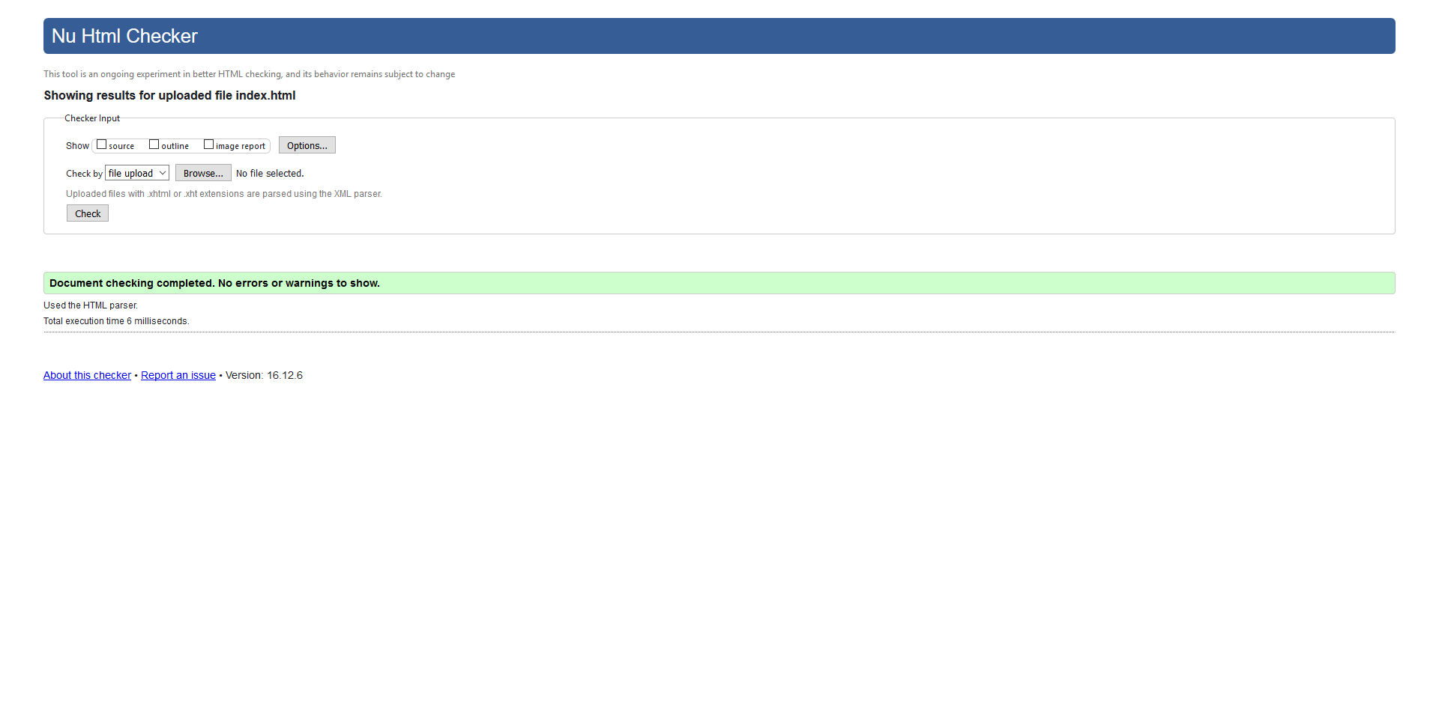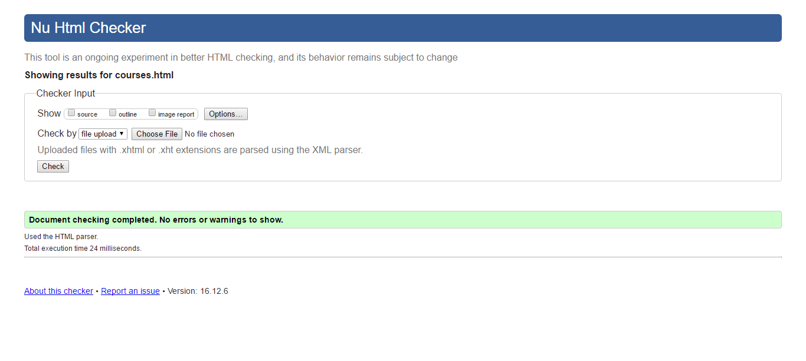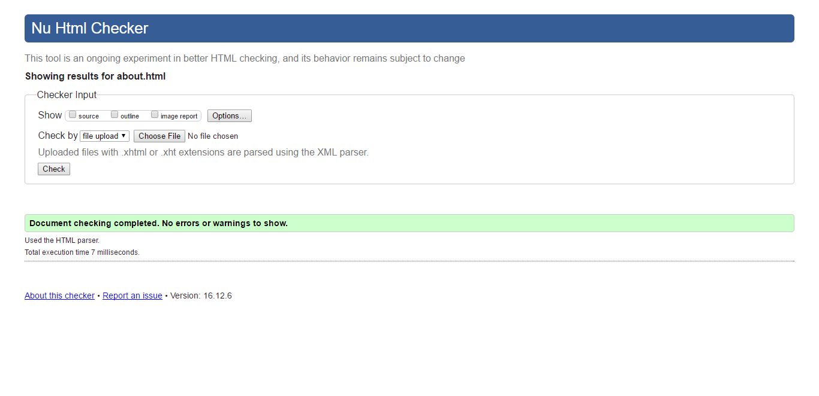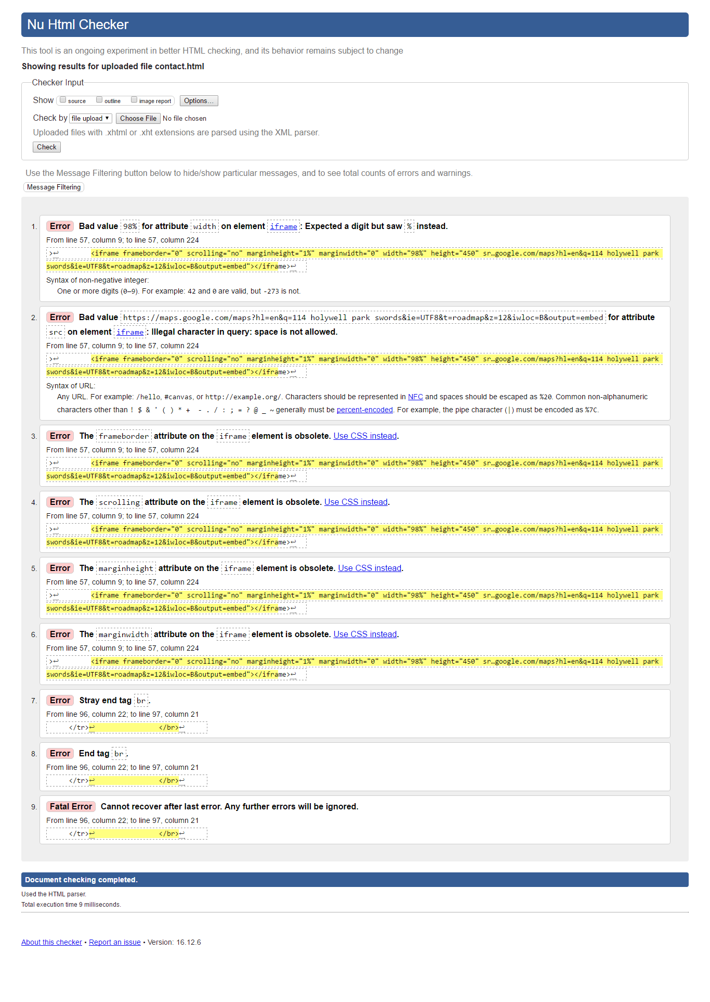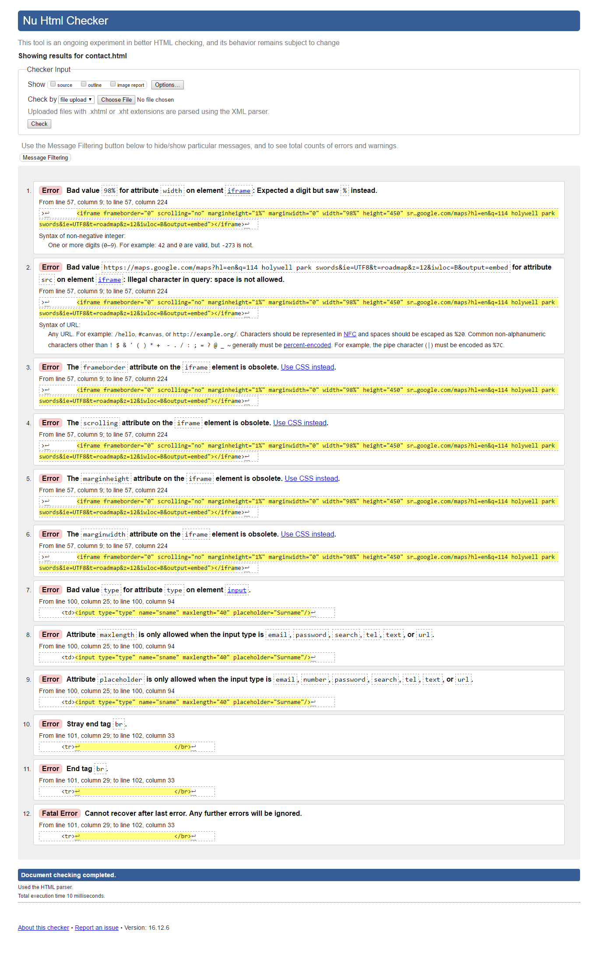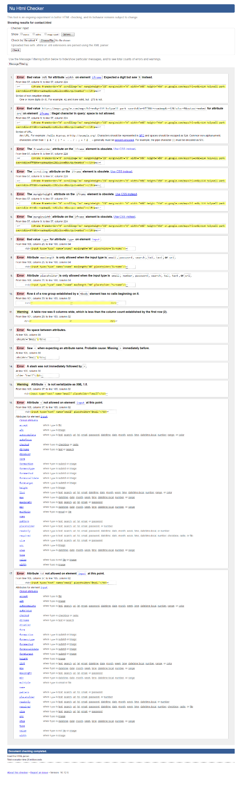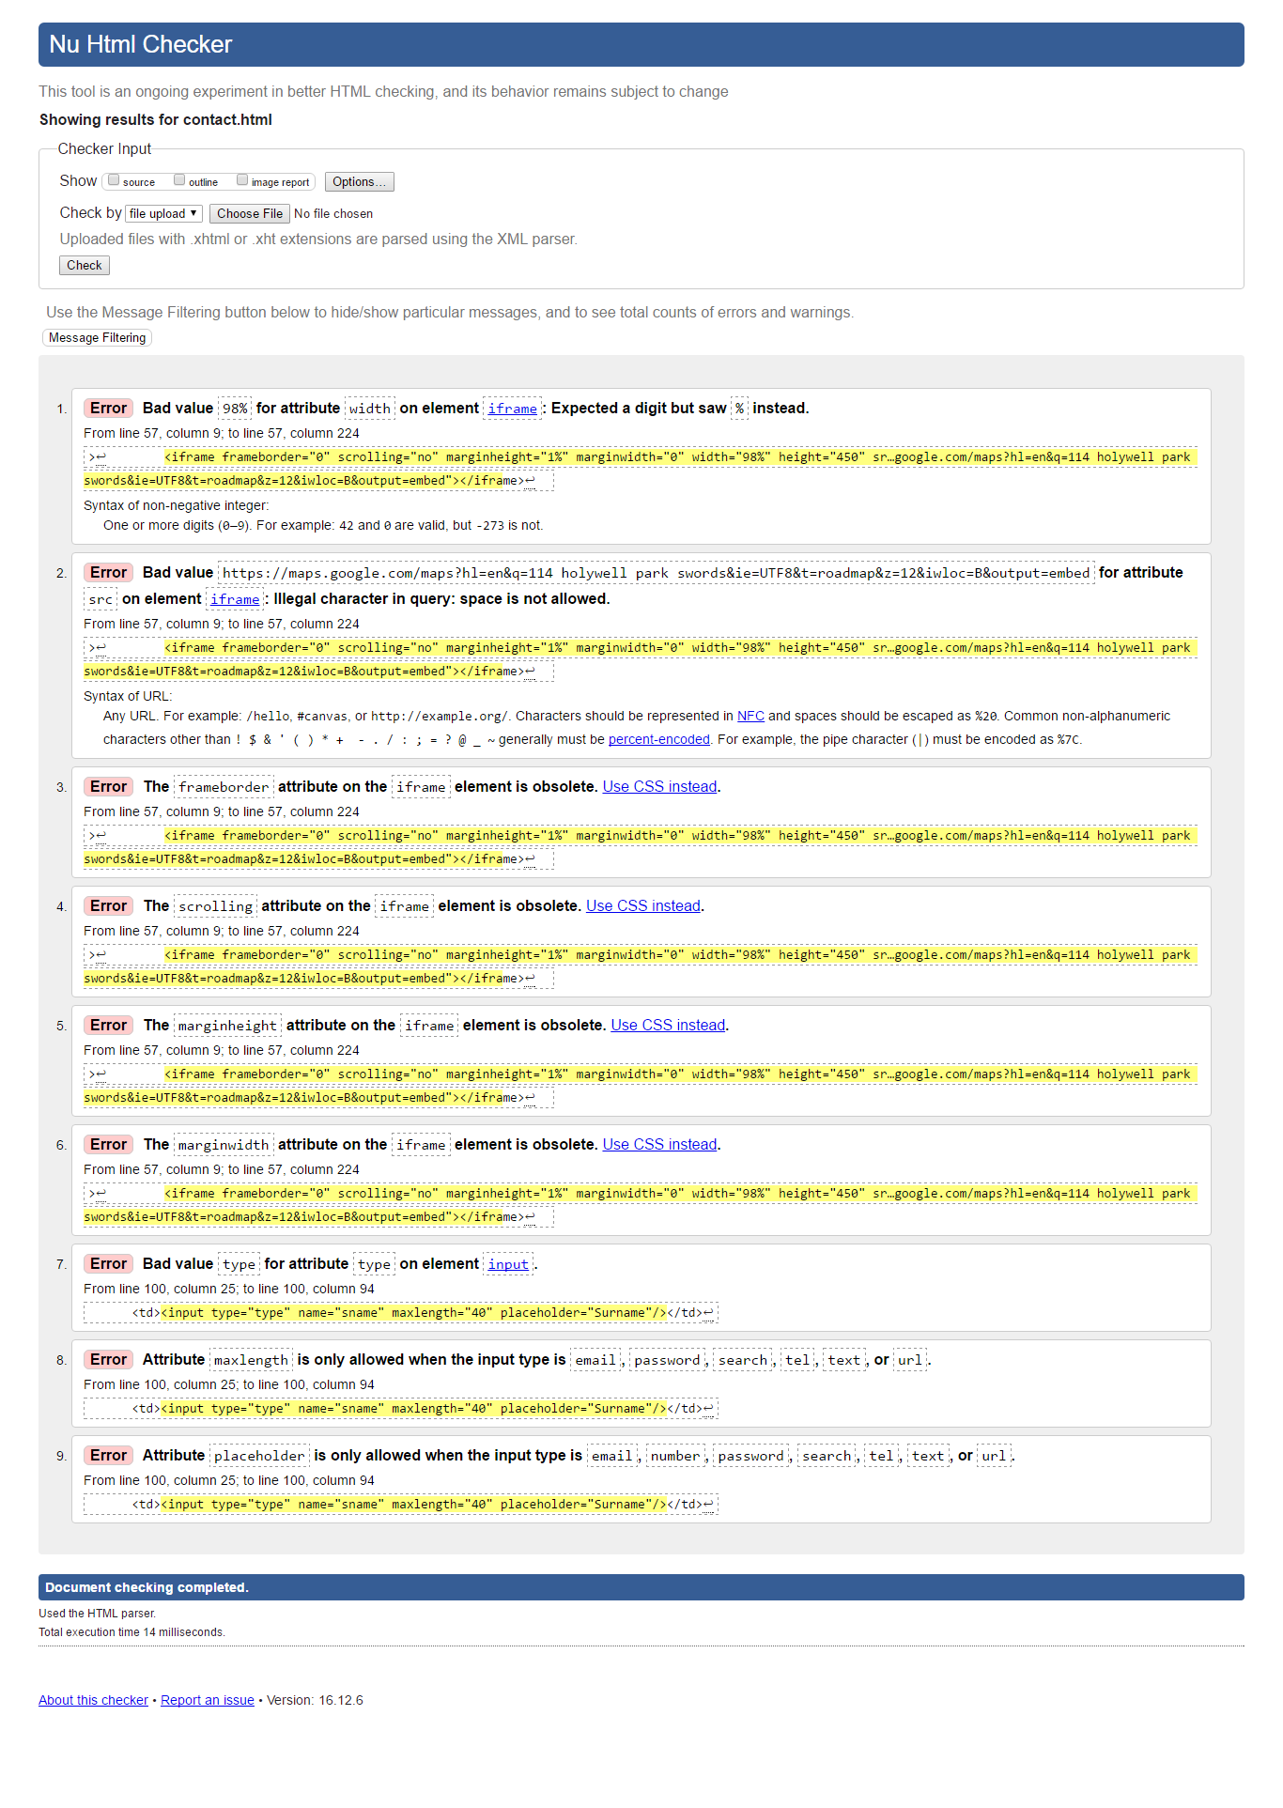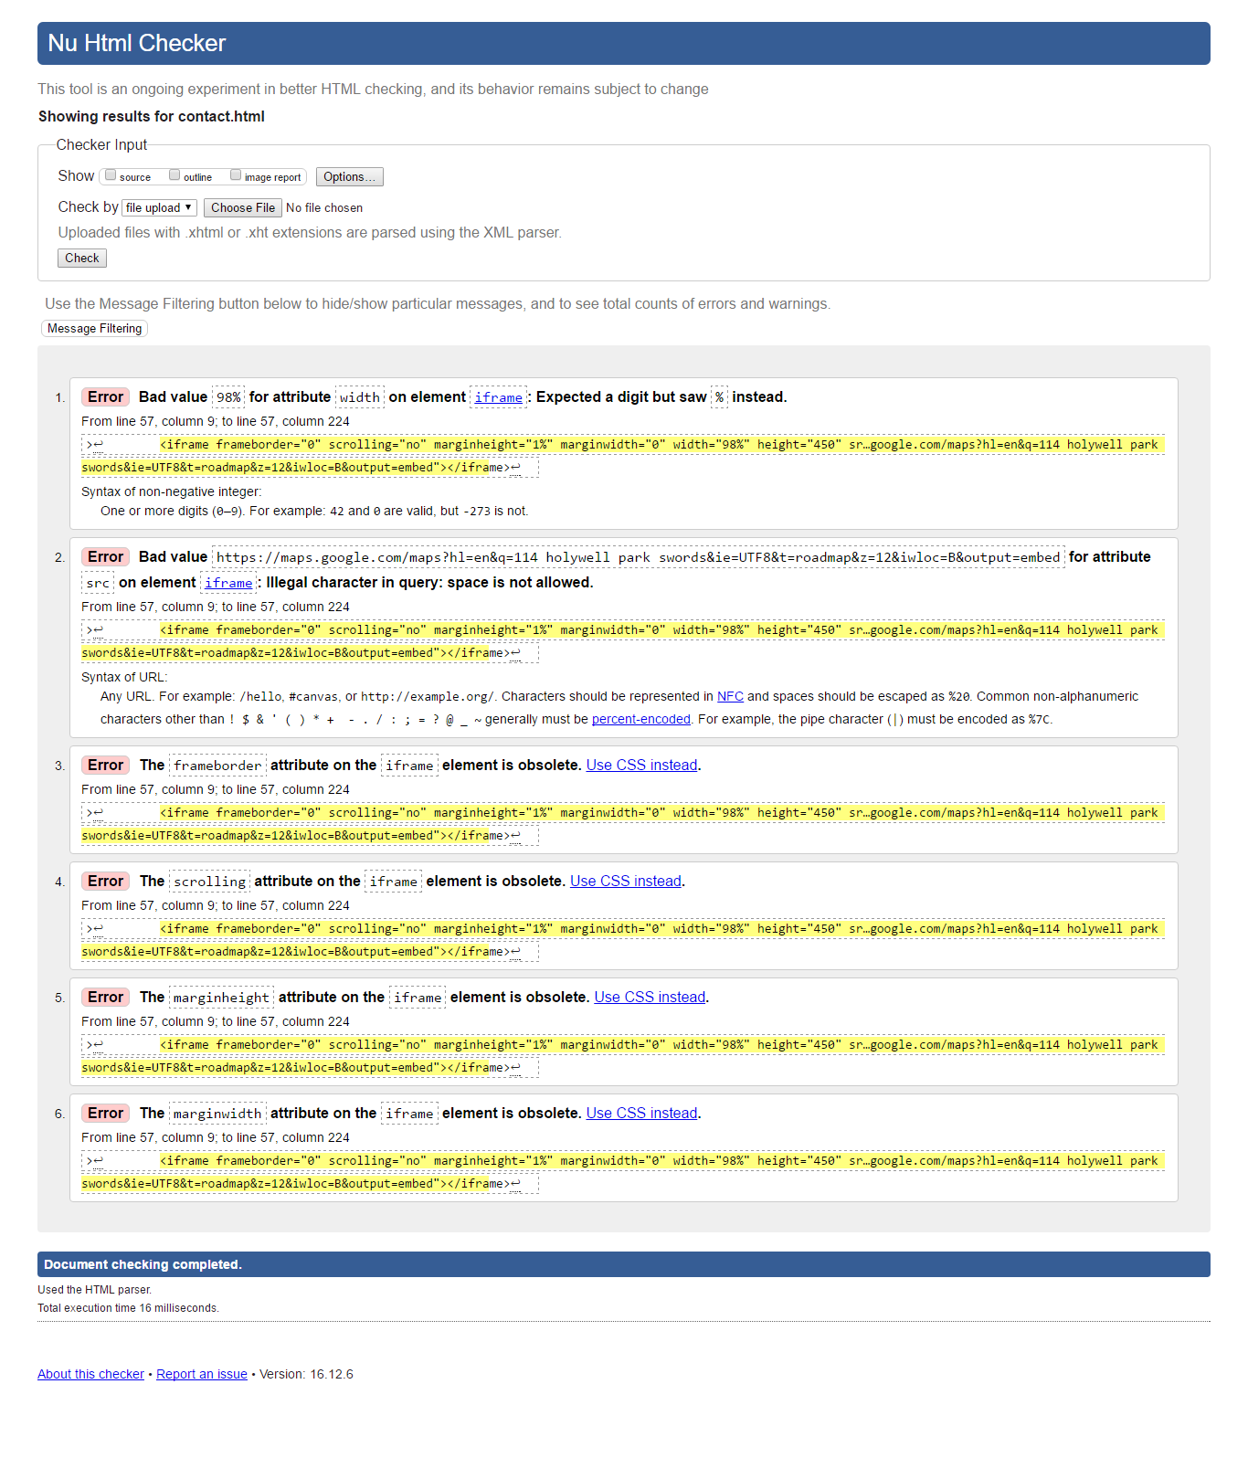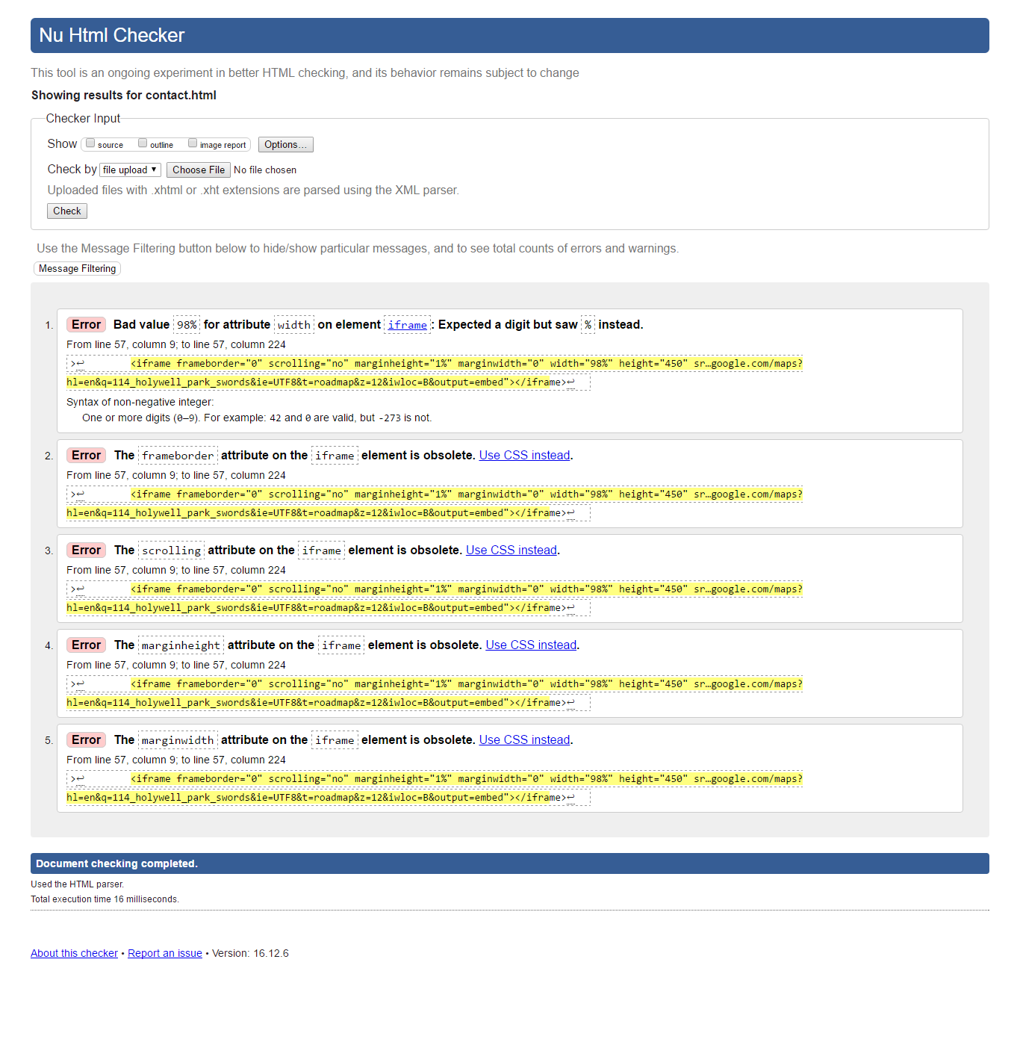

### Deployment

Our [website](http://codemasteracademy.gear.host/index.html) was deployed on GearHost.

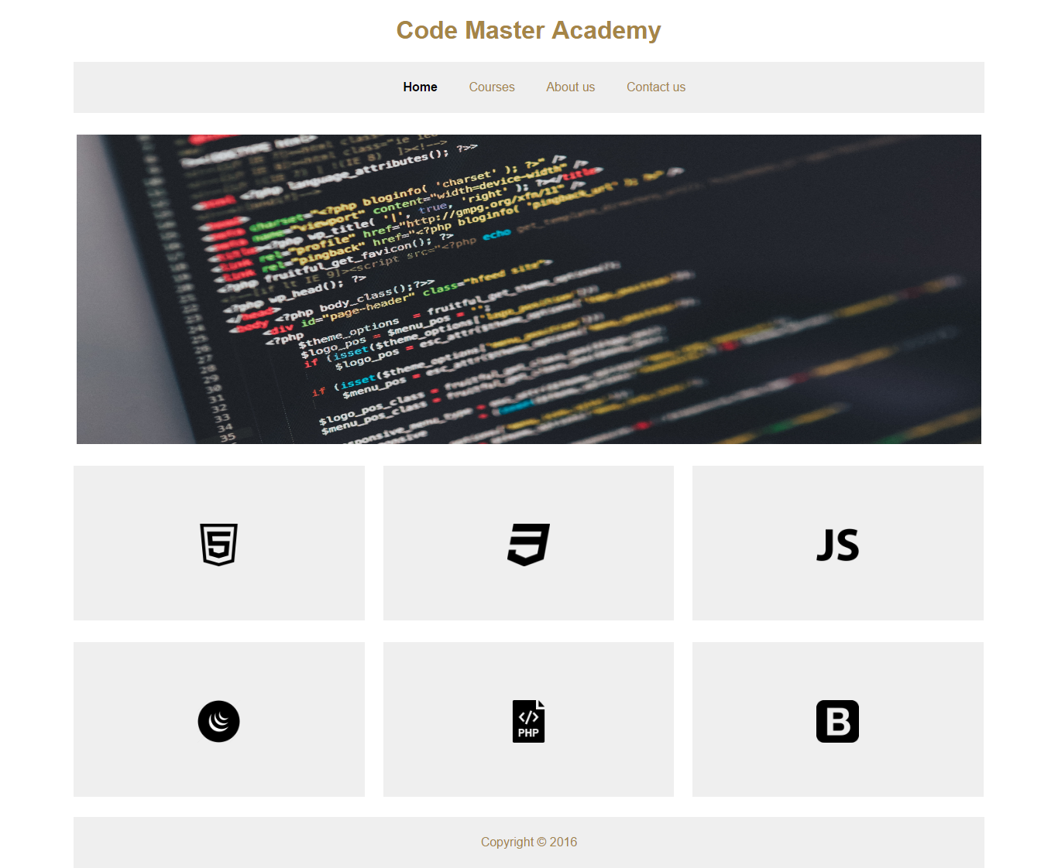

## PROJECT TEAM

### Break Down of Tasks

First of all, we decided what kind of website we would create, after that we started working on potential designs as we would not be able to meet each other very often and we would need to know for sure what we were creating from the beginning in order to achieve our goals. Our first designs were made in paper then we started searching for the content such as pictures and text to be included on the website, after we had the main content for our website we started working with the code, the skeleton of our website using HTML5 was the first thing to be done, after having the first skeleton we started working with CSS3, some of the colours from our first design made on paper had to be changed as they did not look professional on the webpage, most of the parts of the website were created in cooperation, each of us would create something and compare what we had in order to see what was more satisfactory and look better for the users eyes and experience, as both of us had previous experience with web design we were able to implement some of our knowledge into our project shadows, transition and Google Maps API.

Student 1 created the boxes for the icons on the home page and used Google Maps API and Student 2 created the form, tables and searched for the pictures, all the rest was created in conjunction and we were both tweaking each other final design.

### Team Issues

There were no team issues during the project, we did not agree with some of the design at the beginning or what the website would be about, however we worked well as a team and both of us were able to put a little bit of we thought would work well on the webpage without any issues or disagreements.

## CONCLUSION

### Result, Achievements, and Possible Changes to be Added

The project went quite well for us, we planned to do something that would satisfy and fit into our time as it was the most challenging aspect of all the project for both of us, however, our previous experience and knowledge of web design made our goals a little bit easier to achieve, but if had more time to work on it we would have add few more features to it, we would have worked a little bit more with the style, experimented more colours, and developed a site map to the bottom of the page.

But overall it is very satisfying looking to all we built in these weeks and how the website looks and responds.

## REFERENCES & APPENDIX

Anavallasuiza.com. (2016). *What is HTML5?*. [online] Available at: http://anavallasuiza.com/share/presentations/html5/#definitions2 [Accessed 2016].

CSS-Tricks. (2016). *Responsive Data Tables | CSS-Tricks*. [online] Available at: https://css-tricks.com/responsive-data-tables/ [Accessed 2016].

Dev.w3.org. (2016). *Character Entity Reference Chart*. [online] Available at: https://dev.w3.org/html5/html-author/charref [Accessed 2016].

Duckett, J. (2011). 1st ed. Indianapolis: John Wiley & Sons, Inc.

En.wikipedia.org. (2016). *Bootstrap (front-end framework)*. [online] Available at: https://en.wikipedia.org/wiki/Bootstrap_(front-end_framework) [Accessed 2016].

En.wikipedia.org. (2016). *JavaScript*. [online] Available at: https://en.wikipedia.org/wiki/JavaScript [Accessed 2016].

En.wikipedia.org. (2016). *JQuery*. [online] Available at: https://en.wikipedia.org/wiki/JQuery [Accessed 2016].

En.wikipedia.org. (2016). *PHP*. [online] Available at: https://en.wikipedia.org/wiki/PHP [Accessed 2016].

Programming, j. (2016). *jQuery Programming Course | jQuery Training | Learn jQuery*. [online] Traininghott.com. Available at: http://www.traininghott.com/Courses/jQuery-Programming-Course.htm [Accessed 2016].

Programming, P. (2016). *PHP Training | PHP Programming Class | Learn PHP Course*. [online] Traininghott.com. Available at: http://www.traininghott.com/Courses/PHP-Programming-Training-Course.htm [Accessed 2016].

Stocksnap.io. (2016). *Free image of coding, code, programming - StockSnap.io*. [online] Available at: https://stocksnap.io/photo/PFPNV9W5HK [Accessed 2016].

Stocksnap.io. (2016). *Free image of coding, programming, code - StockSnap.io*. [online] Available at: https://stocksnap.io/photo/U3W2SHOLWQ.

Stocksnap.io. (2016). *Free image of office, work, business - StockSnap.io*. [online] Available at: https://stocksnap.io/photo/1PXJWGO765 [Accessed 2016].

Udacity.com. (2016). *JavaScript Basics for Beginners Course | Udacity*. [online] Available at: https://www.udacity.com/course/javascript-basics--ud804 [Accessed 2016].

W3schools.com. (2016). *HTML hr tag*. [online] Available at: http://www.w3schools.com/tags/tag_hr.asp [Accessed 2016].

Website Development with HTML5, C. (2016). *HTML Programming Course | Bootstrap Training Course*. [online] Traininghott.com. Available at: http://www.traininghott.com/Courses/HTML-Bootstrap-Training-Course.htm [Accessed 2016].